**Programming Fundamentals**

**Assignment 04**

**Question 1:**

Write a program that asks user to enter the size of two dynamica2D arrays and populate the arrays using rand().Make a function multiply() that checks if multiplication of both arrays is possible or not. If yes, multiply the arrays.

**Note:** arrays values should be less than 100.

**Sample Output:**

$$A*B=\left[\begin{matrix}1 & 2 & 3 \\ 4 & 5 & 6\end{matrix}\right]*\left[\begin{matrix}9 & 1 \\ 7 & 2 \\ 8 & 4\end{matrix}\right]=\left[\begin{matrix}47 & 17 \\ 119 & 38\end{matrix}\right]$$

**Question 2:**

A file “data.txt” contains the marks details of student obtained from 4 assignments, 6 quiz, 1 Mid-Term, 3 CPs and 1 Final-Term resp. your task if to read data into a dynamic growing 2D array of 5 rows and display the best 2 of assignments, quiz and CP marks as shown in sample Output.

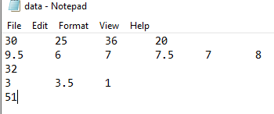

Best 2 Assignment: 30 36

Best 2 Quiz: 9.5 8

Best 2 CPs: 3 3.5